

UNIVERSITI TEKNIKAL MALAYSIA MELAKA
FAKULTI TEKNOLOGI DAN KEJURUTERAAN ELEKTRONIK DAN KOMPUTER

BERR 2243
DATABASE AND CLOUD SYSTEM
Sem 2 2024/2025

2 BERR S1
No | Name | Photo
1 | MUHAMMAD AFIQ AIMAN BIN ABDUL JIDI | B122310413
2 | NUR NADIA NATASHA BT MUHAMMAD TAIB | B122310291
3 | NURUL NAZIERAH BINTI MOHD NIZAR | B122310370

LAB QUESTION:
- POST Request:
- What HTTP status code is returned when a ride is created successfully?
- What is the structure of the response body?
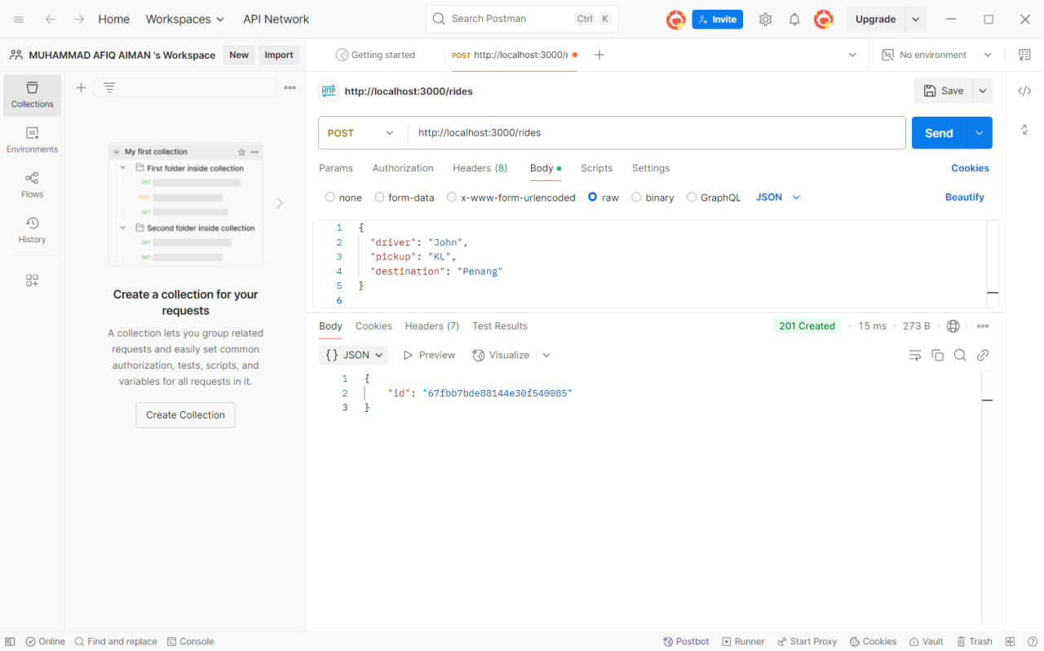
- The HTTP status code returned when a ride is created successfully is 201 Created. This is the status code you received in the Postman response.

- This is the structure:



- GET Request:
- What happens if the rides collection is empty?
- What data type is returned in the response (array/object)?

- It will show an empty ray with status 200 OK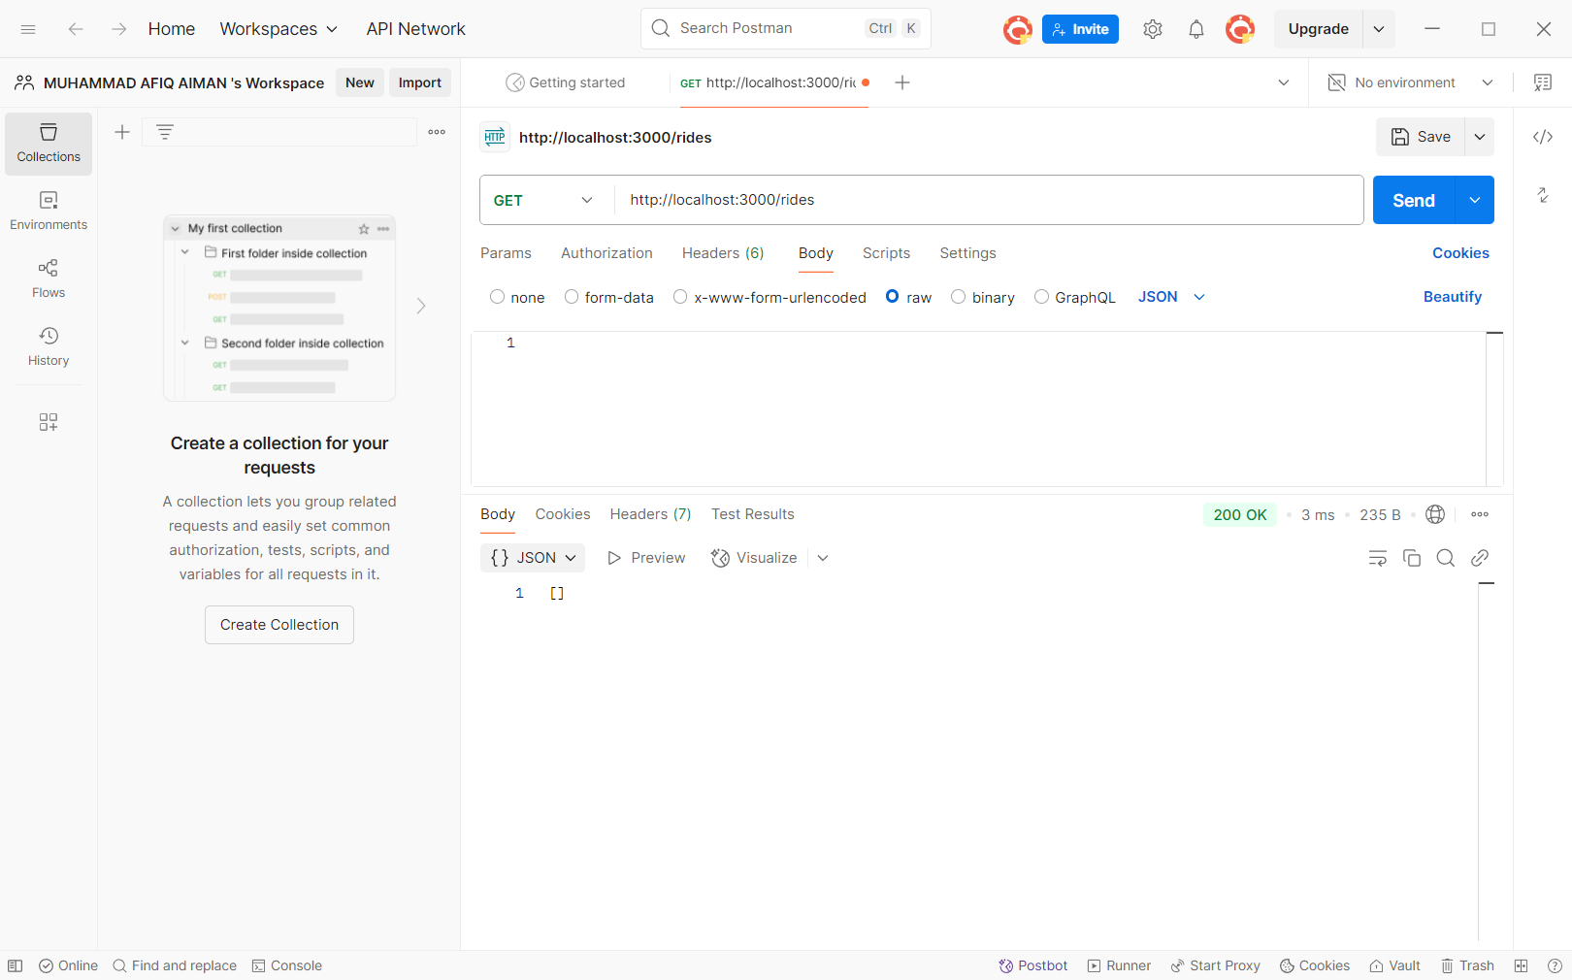

- [
- {
- The response is in ‘aray’ such as: "_id": "...", "driver": "...", "pickup": "...", "destination": "..." "status": "...".
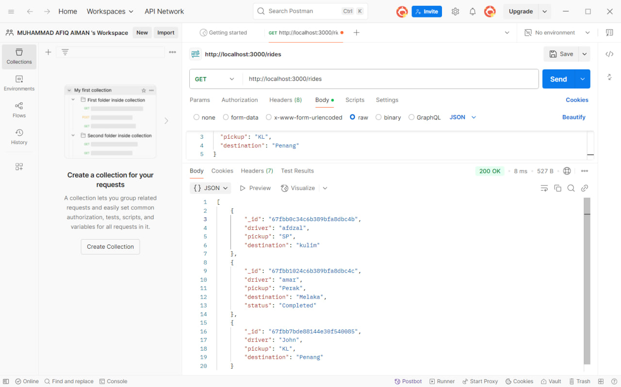
- Fix PATCH and DELETE Error:
- Catch the error when requesting PATCH or DELETE API, then try to fix the issue reported.
- If the ride ID is invalid format, it will return as "error": "Invalid ride ID or data"

- If you try to update a non-existent ride ID, what status code is returned?

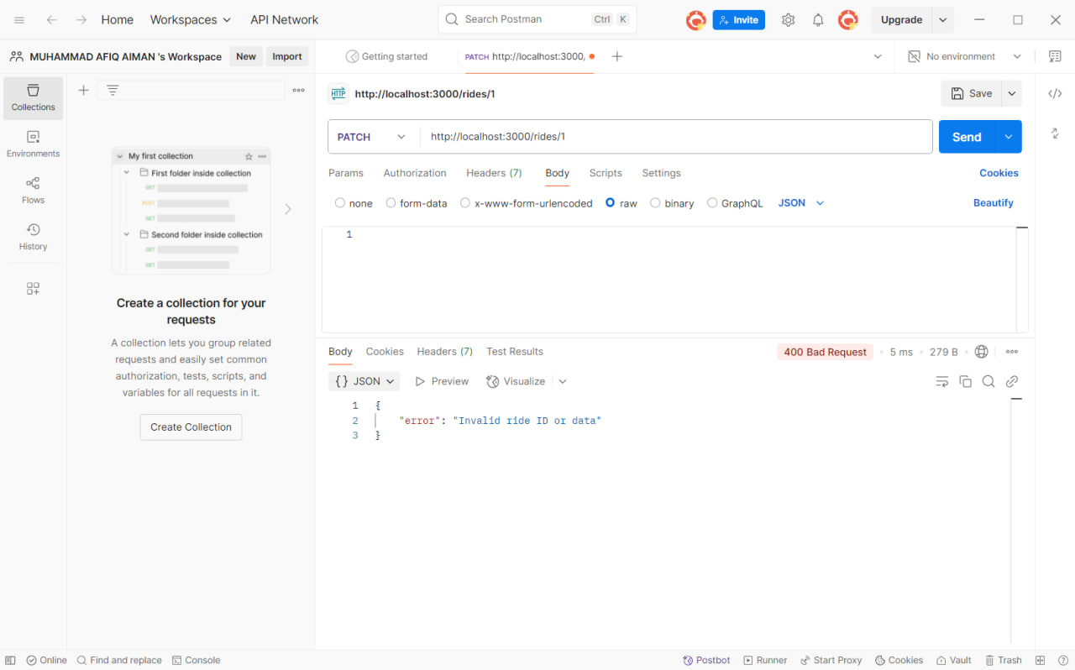
- What is the value of updated in the response if the update succeeds?

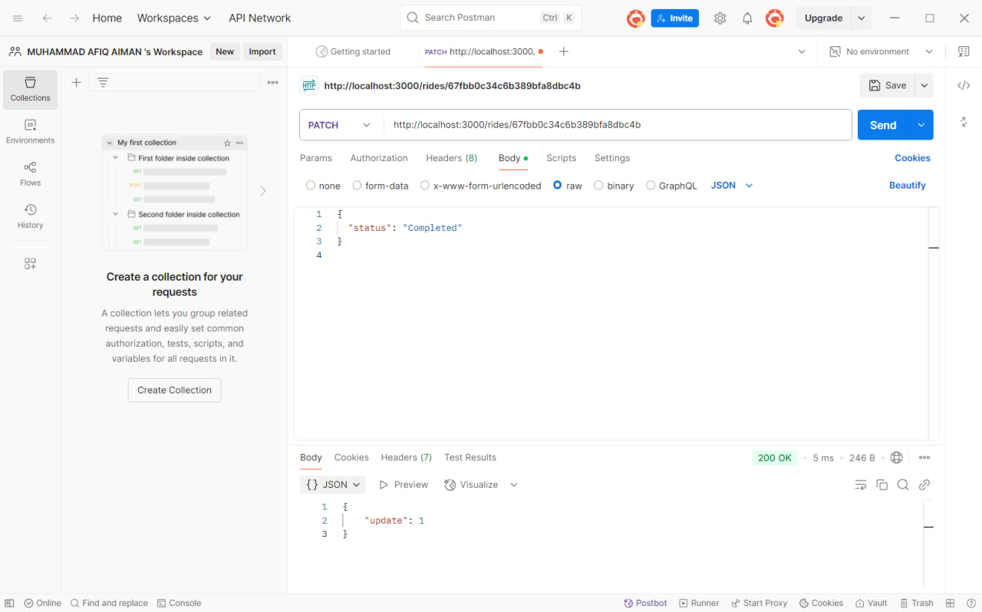
- How does the API differentiate between a successful deletion and a failed one?
- findByIdAndDelete() returns a ride, deletion is successful → deleted: true
- If it returns null, the ride wasn’t found → return 404 Not Found

4.Users Endpoints:
Based on the exercise above, create the endpoints to handle the CRUD operations for users account

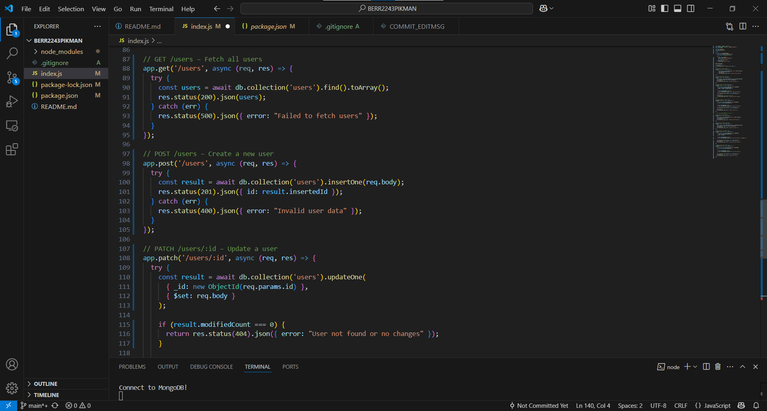
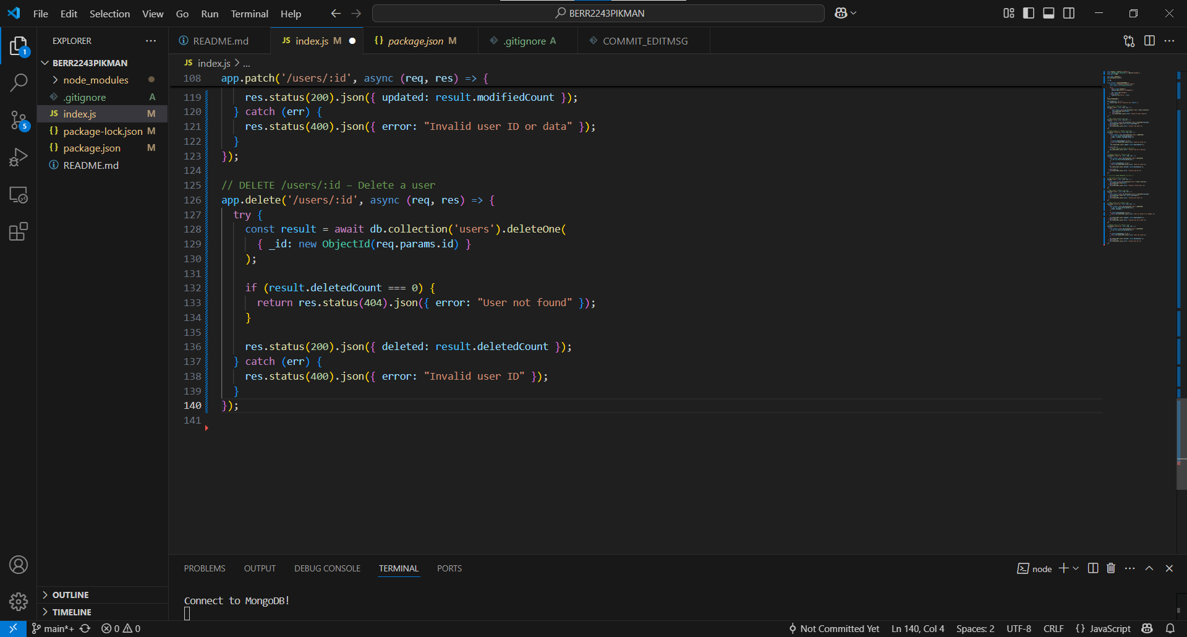

5.FrontEnd:
Upload the Postman JSON to any AI tools, and generate a simple HTML and JS Dashboard for you
